STRUTS 2.0 Dated: 18.09.10

- Struts 2.0 is a framework that is based on MVC Architecture and facilitate productive development of Dynamic Web Applications.
This framework has following characteristics-
  - It is non intrusive.
  - It favors conventions over configurations.
  - It supports Dependency Injection and Aspect Oriented Programming.
  - It is based on Webwork framework of Open Symphony.
  - etc.
- Model View Controller (MVC) – Model View Controller is a design pattern that divides the functionality of an application into three loosely connected modules called Model, View & Controller.
Model represents data, View represents presentation logic and Controller is used to determine the workflow of Application.
- In a Struts Application, Actions represents models.
  - Actions – An Action represents request data and its processing logic as a single unit.
  - Results – JSP pages are used to generate presentation for the end-user. JSP pages are managed by Results. A Result is a framework component that is responsible for using JSP pages for generating views.
  - Controller – In a Struts Application Controller is implemented as a filter which intercepts all the request of Web Application and controls its work flow. Controller provides a single entry point to the Web Application.
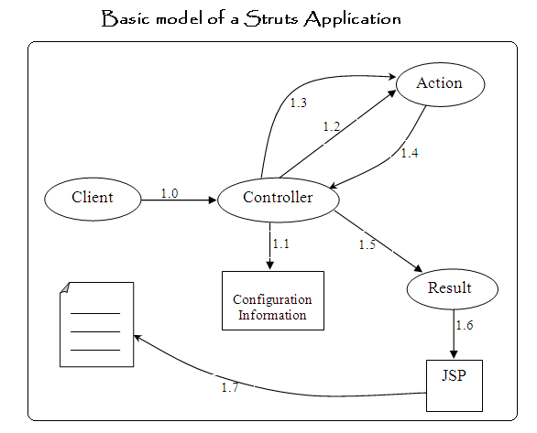
1.0 | Request
1.1 | Configuration Information is read to find out Action & Result for the request.
1.2 | Action is initiated and populated with Request data.
1.3 | Action is asked to process request.
1.4 | Request is processed and a String is returned.
1.5 | Result is invoked and URL of JSP pages for the returned String is provided.
1.6 | JSP is invoked.
1.7 | View for end user is generated.

- ValueStack- ValueStack is a virtual object that exposes properties of objects added to it as the properties of its own. Concept of ValueStack is introduced to provide a single location for storing data of a Request which eliminates the need of passing data from one component to another.
For each request, Controller creates a ValueStack object and stores all the data required in the processing of request including Action object to the ValueStack.
All the components which participate in request processing stores, read and change data in the ValueStack.
- OGNL (Object Graph Navigation Language)
  - To facilitate non-programmatic access to the data of ValueStack an expression language called OGNL is introduced. Application Programmers uses OGNL expressions to target data in the ValueStack.
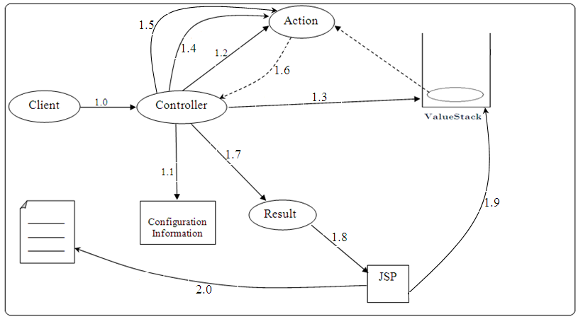
1.0 | Request
1.1 | Configuration Information is read to find out Action & Result for the request.
1.2 | Action is instantiated.
1.3 | ValueStack is created and Action is pushed into ValueStack.
1.4 | Action is get populated by Request data.
1.5 | Action is asked to process request.
1.6 | Request is processed and a String is returned.
1.7 | URL & JSP is provided and Result is invoked.
1.8 | JSP is invoked.
1.9 | Data is fetched from the ValueStack using OGNL expressions.
2.0 | View is generated for end user.

- Dependency Injection – It is a means of implementing Inversion of Control (IOC).
  - Inversion of Control (IOC) is a design strategy that was proposed by Spring Framework. This strategy proposes that an Application must not be concerned with creation of objects rather it should focus on the usage of objects.
  - There are two approaches of implementing Inversion of Control (IOC)-
    - DI (Dependency Injection) – In Dependency Injection, dependencies of an object are satisfied unasked i.e. before the object is asked to perform its task, all the resources or data is provided to the object.
    - DL (Dependency Lookup) – In case of Dependency Lookup, an object ask the resources & the data required by it to perform its functions, then these resources & data are provided to the object.
- Aspect Oriented Programming – In the processing of each request in a Web Application there are multiple task such as setting up request parameters to Application objects, Type Conversion, Exception Handling, Validation etc. which need to be performed.
  - Aspect Oriented Programming provides a convenient model of implementing all these functionalities in a Web Application with the help of interceptors. An interceptor is a proxy object that provides the implementation of an additional concern which is required in the processing of a request.
Struts 2.0 framework provides a set of predefined interceptors each of which represents the implementation of a service that is to be provided to the Action. These interceptors are fired by the Controller before the Action is invoked.

Detailed Model of Struts 2
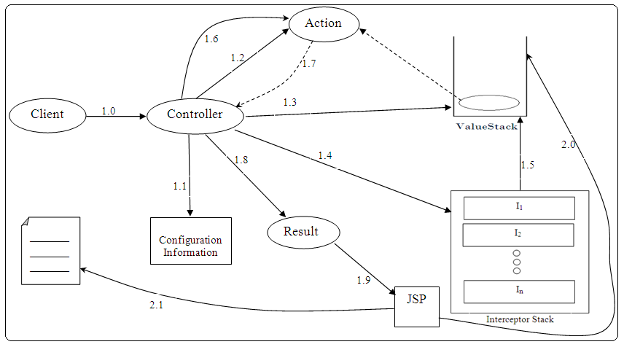

1.0 | Request
1.1 | Configuration Information is read to find out Action, Interceptors & Result for processing the request.
1.2 | Action is created.
1.3 | ValueStack is created and Action is pushed.
1.4 | Interceptors are invoked.
1.5 | Interceptors apply their services to the Action.
1.6 | Action is asked to process request.
1.7 | String is returned.
1.8 | URL of JSP is provided and Result is invoked.
1.9 | JSP is invoked.
2.0 | Data is obtained from the ValueStack using OGNL expressions.
2.1 | Result for end user is generated.
Dated: 19.09.10
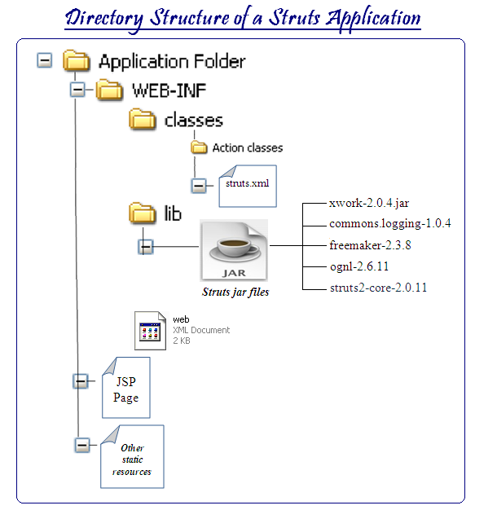
- Controller, Interceptors and Results are provided by the framework. An Application Developer need to define only Action class & Configuration Information.

  - org.apache.struts2.dispatcher.FilterDispatcher is a Filter provided by framework that acts as Controller, i.e. entry of the Filter need to be made in web.xml.

- 3rd Step(Create Action class)
  - Defining Actions- An Action is implemented by POJO (Plain Old Java Object) class that contains data members to store request data. Their getter and setter methods and a method that represents processing logic which returns a String and doesn’t receive any parameters (Conventionally it is named execute () method).

  - package mypack;

public class LoginAction{

private String name, password;

public String getName(){
return name;
}

public void setName(String name){
this.name = name;
}

public String getPassword(){
return password;
}

public void setPassword(String password){
this.password = password;
}

public String execute()
{
if name.startsWith(“a”) && password.startsWith(“b”));
return “ok”;
else
return “error”;
}
}

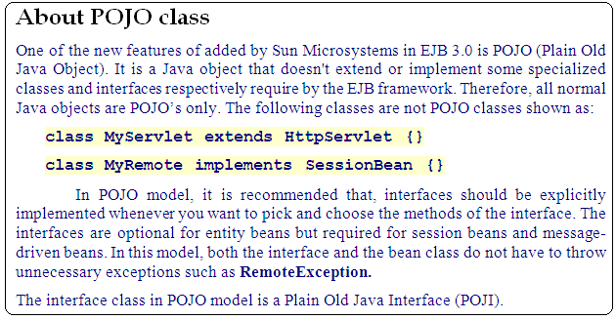

- 4th Step (Define JSP Pages)
  - In JSP pages Custom Tags of Struts Tag Library are used to generate presentation logic.

- ActionContext is a class provided by the framework. An object of type ActionContext is created by the Controller for each request to hold ValueStack and other Servlet API objects which are required in the processing of a request.

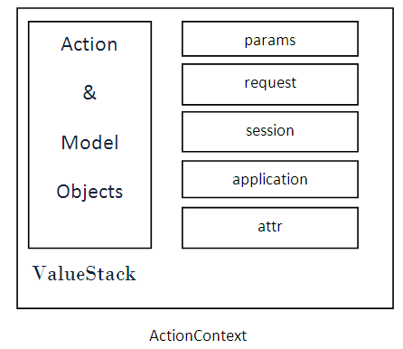

Apart form ValueStack, ActionContext contains following objects:-
  - params is a map of request parameters.
  - request is a map of attributes added to the request object.
  - session is a map of attributes added to the session scope.
  - application is a map of attributes added to the application scope.
  - attr is a utility object that facilitate searching of attributes in request, session and application scope in the same order.

[Note: ValueStack is the default object of ActionContext that is properties of ValueStack are
directly referred.]

To refer properties of other objects following syntax is used:-
#objectname.propertyName

Example-
If an attribute named “con” is saved in application scope then it can be referred using following OGNL expression:-
#application.con

- ActionInvocation is a class provided by framework. An object of type ActionInvocation is created by the framework for each request. This object is responsible for controlling the workflow of request processing. It exposes one method named invoke() method that is used by the Controller to start request processing.
public String invoke();

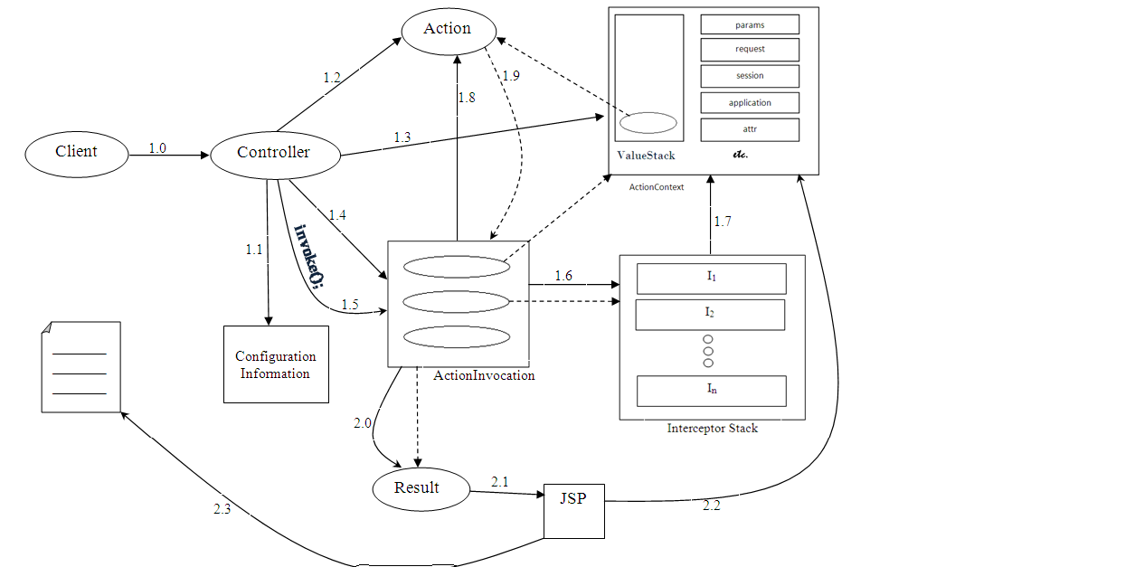

1.0 | Request
1.1 | Configuration Information is read to find out Action, Interceptors & Result.
1.2 | Action is Instantiated.
1.3 | ActionContext is created & populated.
1.4 | ActionInvocation is created.
1.5 | ActionInvocation is asked to start processing.
1.6 | Interceptors are fired.
1.7 | Pre-processing logic is applied by Interceptors.
1.8 | Action is invoked.
1.9 | String is returned.
2.0 | Result is invoked.
2.1 | JSP is invoked.
2.2 | Data is fetched from ActionContext.
2.3 | View is generated.

- Understanding Interceptors
  - Interceptors are proxy objects which are used to apply pre-processing and post-processing logic to a request processing.
Functionality of an interceptor is described by an interface named Interceptor provided by the framework.

This interface provides life cycle methods of an Interceptor.
- init() method is invoked only once just after an Interceptor is created. It is used by the Application Developers to perform some initialization.

- intercept() method is invoked each time a request for the action is received on which Interceptor is applied.
public String intercept(ActionInvocation ai);
This method is used by the Application Developer to define pre-processing logic and to request the invocation of next Interceptor or Action or to display the result i.e. each Interceptor has the capacity to change the workflow of request processing by returning a String on its own from the intercept() method.

- destroy() method is invoked only once just before an Interceptor is unloaded.
public void destroy();

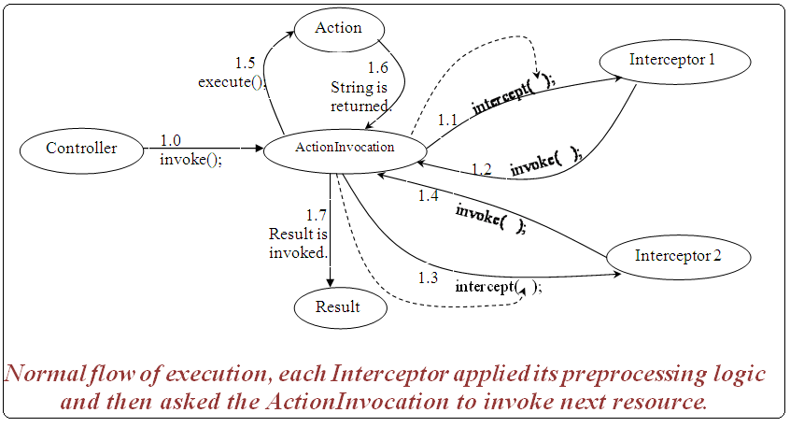

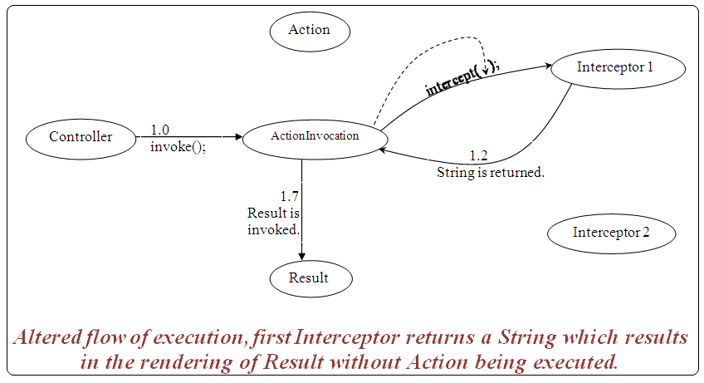
Dated: 25.09.10

- Understanding Result –Result is a framework component that is responsible for invoking JSP pages. Functionality of a Result is described by an interface named Result.
This interface provides one method.
public void execute (ActionInvocaton ai);
This method is invoked by the ActionInvocation when a String is returned to it either by an
Interceptor or by the Action.

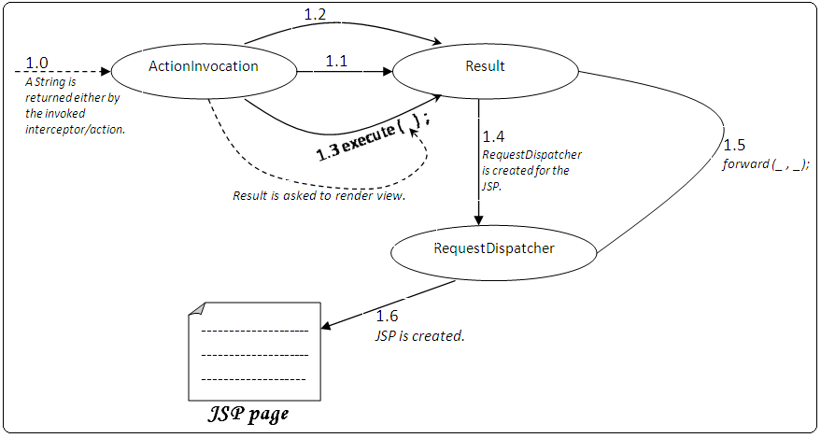

1.1 | Value of static final String property DEFAULT_PARAM of Result is read.
1.2 | Using the value of DEFAULT_PARAM, setter method is identified and invoked to provide the name of JSP to result.

Dated: 26.09.10
- Commonly used predefined interceptors
  - params-This interceptor is responsible for transferring value of request parameters to action properties in ValueStack.
This interceptor is part of the default stack.
  - Model Driven –This interceptor is used to push a model object return by the Action on top of ValueStack so that its properties can be directly referenced.
Sometimes an Action contains reference of other objects i.e. a chain of objects is represented by Action. In such a case to refer the property of change objects lengthy OGNL expressions are required.

For example-
In order to refer city, stated & pincode of user following OGNL expressions are required:-
user.address.city
user.address.state
user.address.pincode

With the help of Model Driven Interceptor, Address is pushed on top of ValueStack so that its properties can be directly referenced.
Model Driven Interceptor works in association with Model Driven Interface provided by the framework. In order to use Model Driven Interceptor, Model Driven Interface needs to be implemented by the Action. This interface provide one method.
public Object getModel ( );
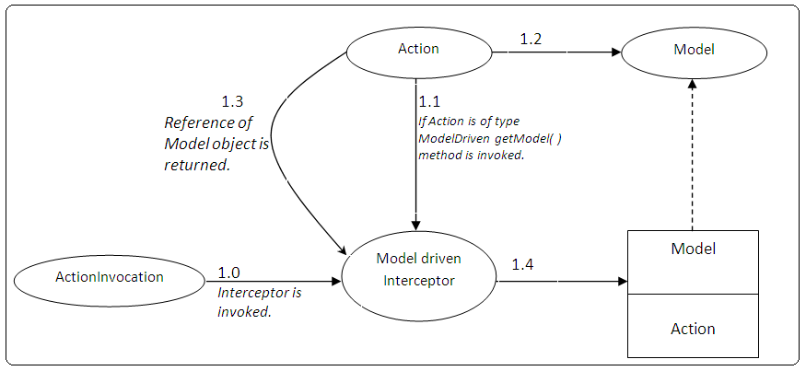
For figure-
1.0 Interceptor is invoked.
1.2 A model object is created from getModel( ) method.
1.3 Reference of Model object is returned.
1.4 Model object is pushed on top of ValueStack.

  - servletCofig – This interceptor is used to inject Servlet API objects into the Action. This interceptor works in association with following interfaces-
Interfaces | Method
ServletConfigAware | public void setServletConfig(ServletConfig config);
ServletRequestAware | public void setServletRequest(ServletRequest request);
ServletContextName | public void setServletContext(ServletContext context);
HttpSessionAware | public void setHttpSession(HttpSession session);

Dated: 09.10.10
- workflow interceptor is used to validate Action properties. This interceptor requires following interfaces to be implemented by the Action.

Validation & ValidationAware
- Validatable interface provides a single method named validate() method that is defined by the Application Developer & contains validation logic.

public void validate( ) throws Exception;

- ValidationAware interface provide methods to manage error messages.

Commonly used methods of this interface are-
public void addFieldError(String fieldName, String errorMsg);
public String getFieldError(String fieldName);
public boolean hasErrors();
etc.

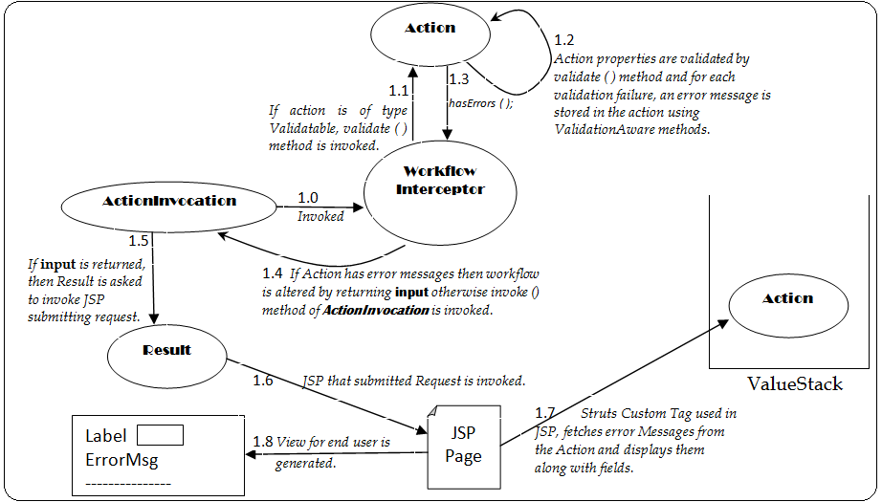

1.3 | Checks whether action has some Error Messages or not.

- To simplify implementation of the ValidationAware & other interfaces framework provide a class named ActionSupport that is used as a base class for defining Actions. It implements following interfaces-

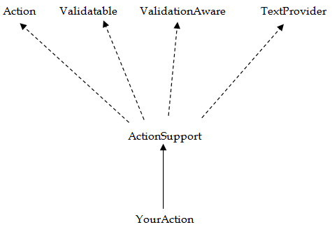

- TextProvider interface provides methods for obtaining text from Properties files.

Example-

  - LoginAction.java

import com.opensymphony.xwork2.ActionSupport;

public class LoginAction extends ActionSupport
{
private String name, password;

public void validate() {
if(name.length()==0)
this.addFieldError("name", "Name is required.");
if(password.length()==0)
this.addFieldError("password", "Password is required.");
else if(password.length()<4)
this.addFieldError("password", "Password should be of atleast 4 characters.");
}

public String getName() {
return name;
}

public void setName(String name) {
this.name = name;
}

public String getPassword() {
return password;
}

public void setPassword(String password) {
this.password = password;
}
}

  - struts.xml

<!DOCTYPE struts PUBLIC
"-//Apache Software Foundation//DTD Struts Configuration 2.0//EN"
"http://struts.apache.org/dtds/struts-2.0.dtd">

<struts>
<package name="default" extends="struts-default">
<action name="login" class="mypack.LoginAction">
<result name="success">/welcome.jsp</result>
<result name="input">/index.jsp</result>
</action>
</package>
</struts>

  - web.xml

<?xml version="1.0" encoding="UTF-8"?>

<web-app>

<filter>
<filter-name>f1</filter-name>
<filter-class>org.apache.struts2.dispatcher.FilterDispatcher</filter-class>
</filter>

<filter-mapping>
<filter-name>f1</filter-name>
<url-pattern>/*</url-pattern>
</filter-mapping>
</web-app>

  - index.jsp

<%@ taglib uri="/struts-tags" prefix="s" %>

<s:form action="login">
<s:textfield name="name" label="Name" />
<s:password name="password" label="Password" />
<s:submit value="login" />
</s:form>

  - welcome.jsp

<%@ taglib uri="/struts-tags" prefix="s" %>
<b> Welcome, <s:property value="name" /> </b>

- See the figures related to this program-

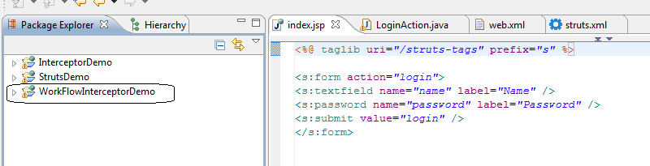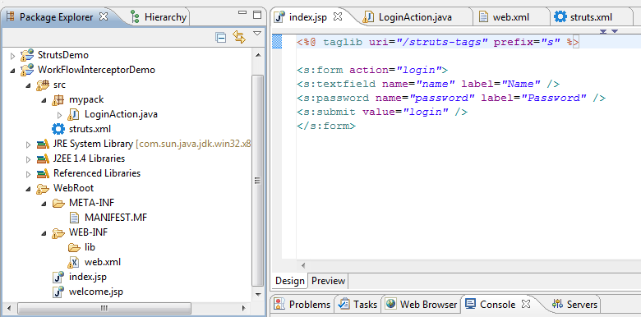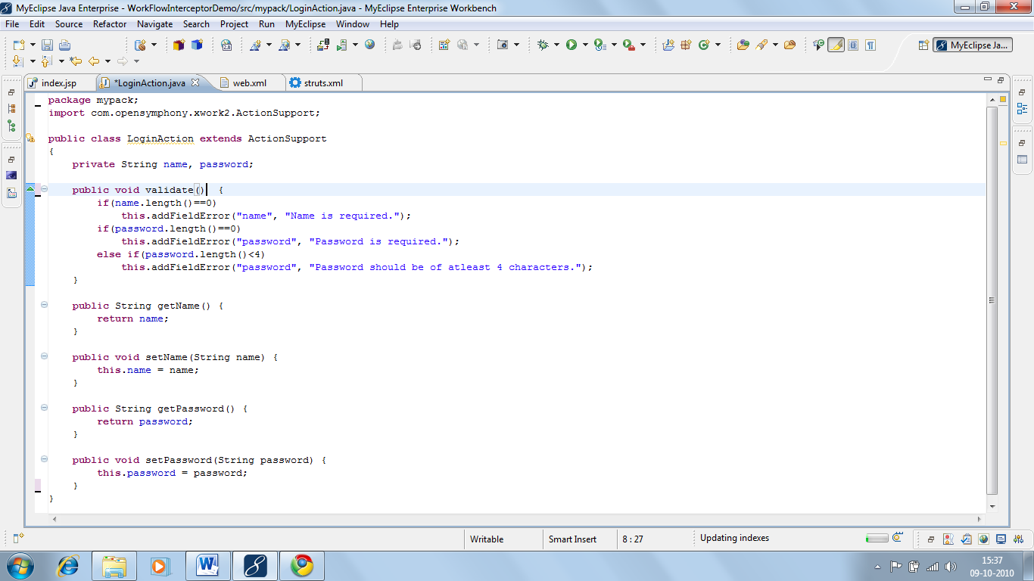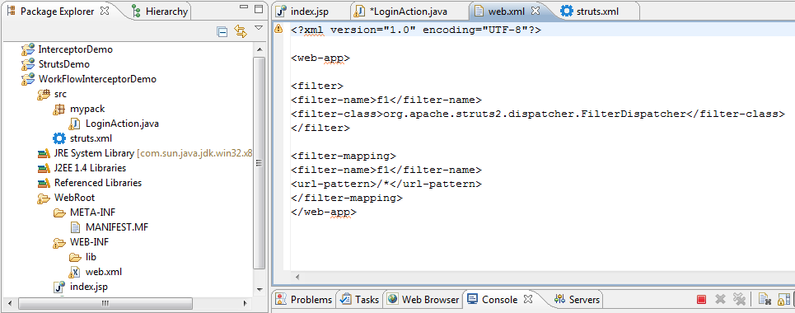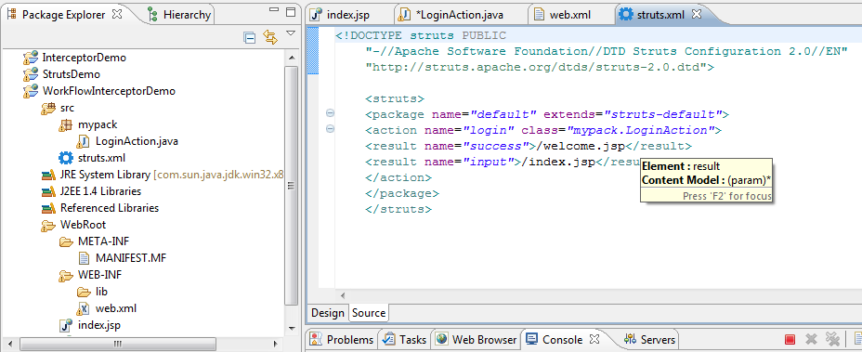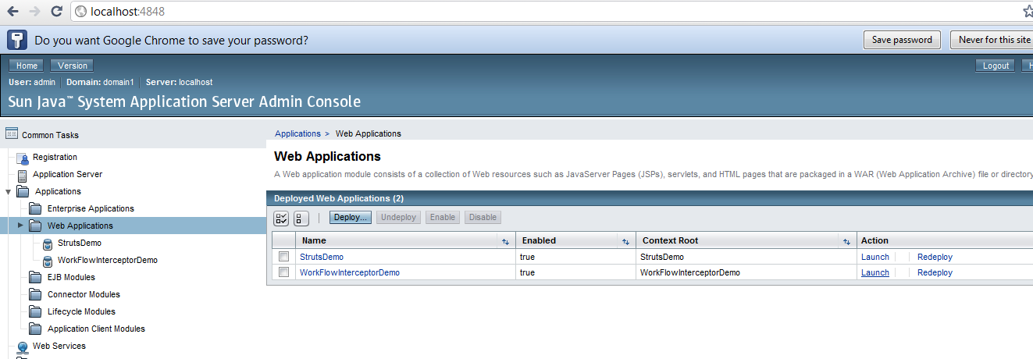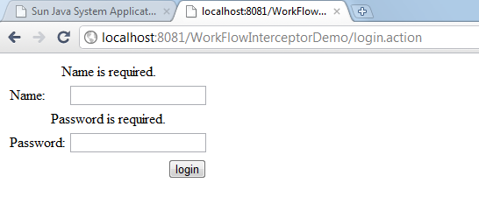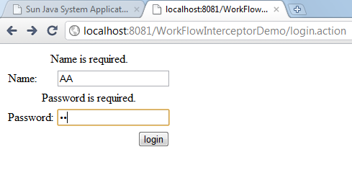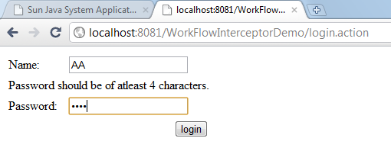
- Validations of framework-

Struts Framework provides an optional sub framework for applying common validations such as required, range, regular expression, keyname etc. on Action properties.

Validations of framework consists of validators (classes that encapsulates validation logic), validation Metadata (XML files that logically identifies validators by names), and validation interceptor.

In order to use validation framework for validating Action properties, an XML file for the Action is created. This XML file contains the mapping of Action fields and predefined validators.
This file is conventionally named as follows-
ActionName-validation.xml

- Diagram
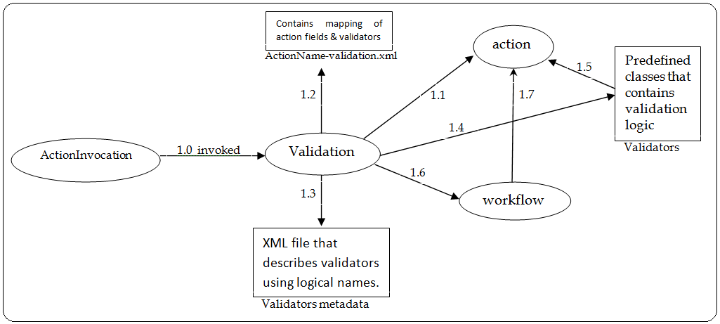
1.0 | Invoked.
1.1 | ActionName is obtained.
1.2 | Using ActionName, validation Mapping file is identified.
1.3 | Using validator MetaData, validator classes for the applied validators are identified.
1.4 | Validators are invoked.
1.5 | Action fields are validated & error Messages if any are saved.
1.6 | Workflow interceptor is invoked.
1.7 | validate ( ) method is invoked, Action is checked for error Messages and if error Messages are found, workflow is altered.

- Commonly used predefined validators are-
  - required - is used to check whether a field is empty or contains some value. Empty strings are considered as value by this validator.
  - requiredstring – same as required except empty strings are not considered as value.
  - int, double & date – are used to check whether given number for date is within specified range or not.
  - email - is used to check whether Mail ID is in proper format or not.
  - stringlength – is used to check whether a String length lies within given renge or not.
  - regex – is used to validate the value of a field using a regular expression.

All the predefined validators can be divided into 2 categories-
- Validators that need additional information apart from field name int, double, date, stringlength & regex are validators of this category.
- Validators which don’t require additional information other than field name, required, requirestring, email etc are validators of this category.

Example-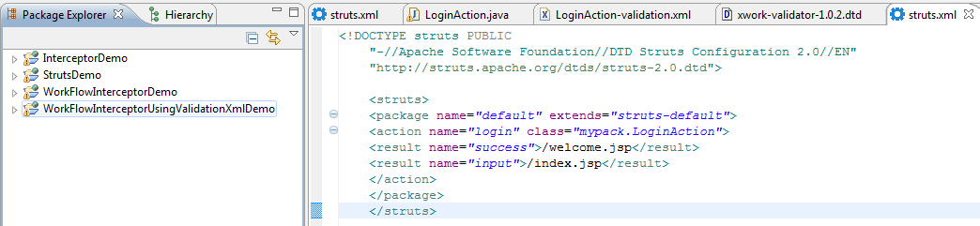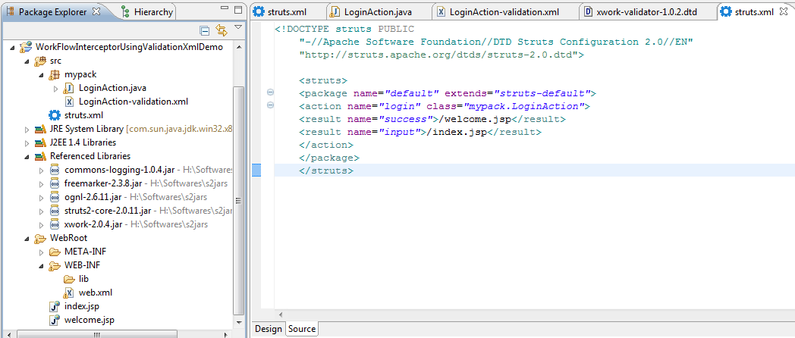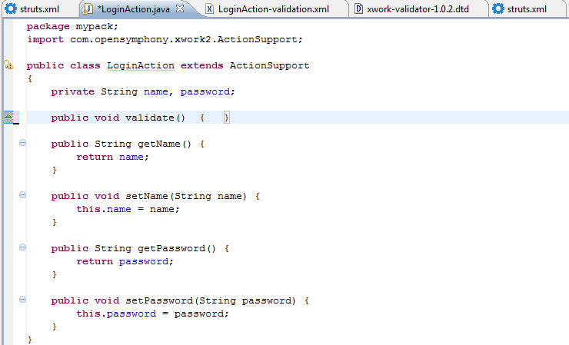
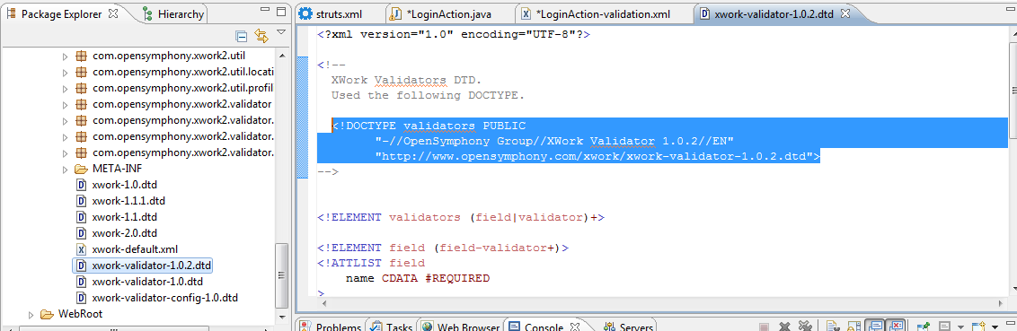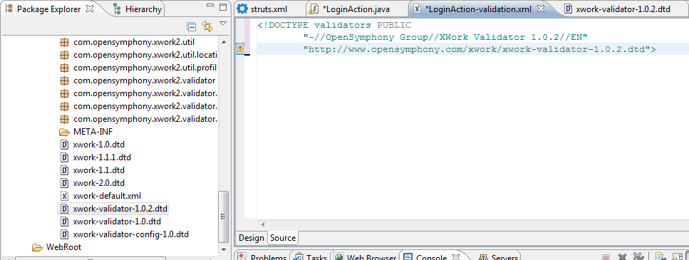
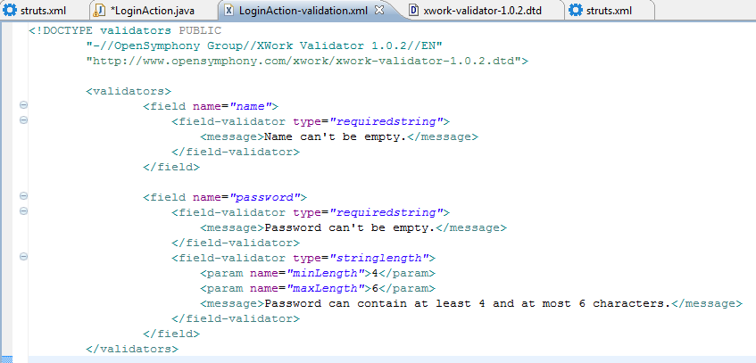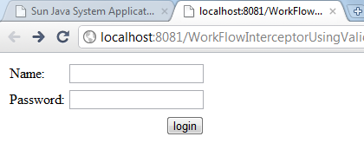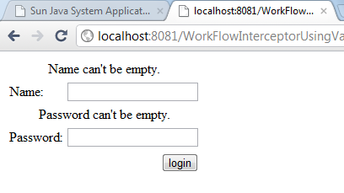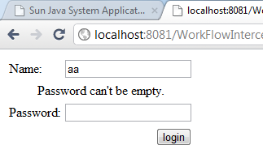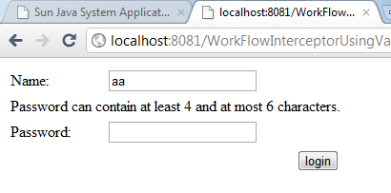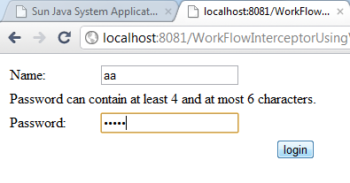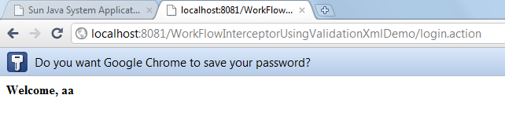

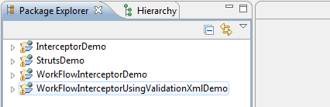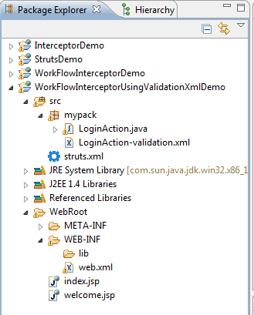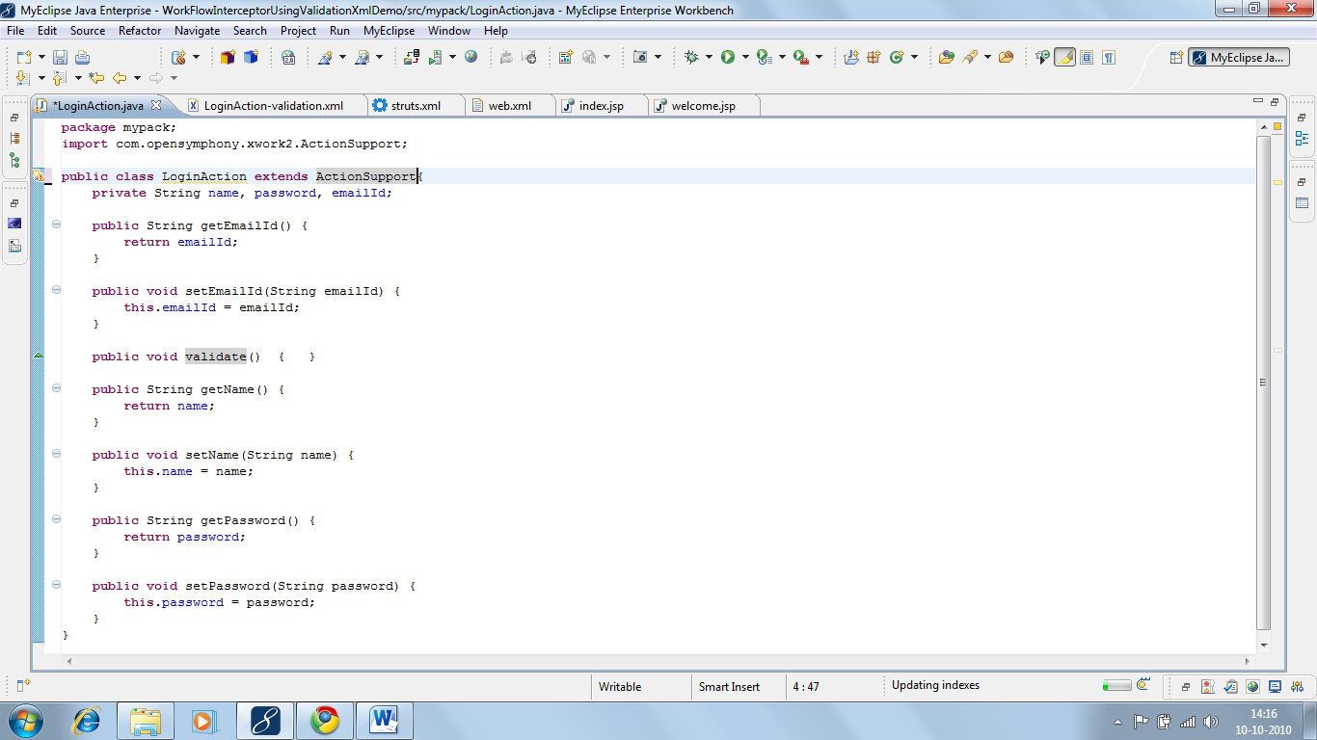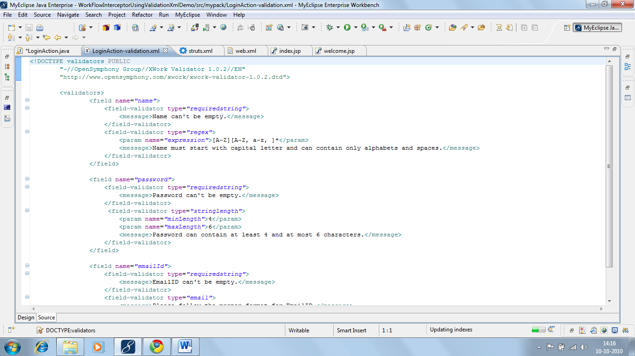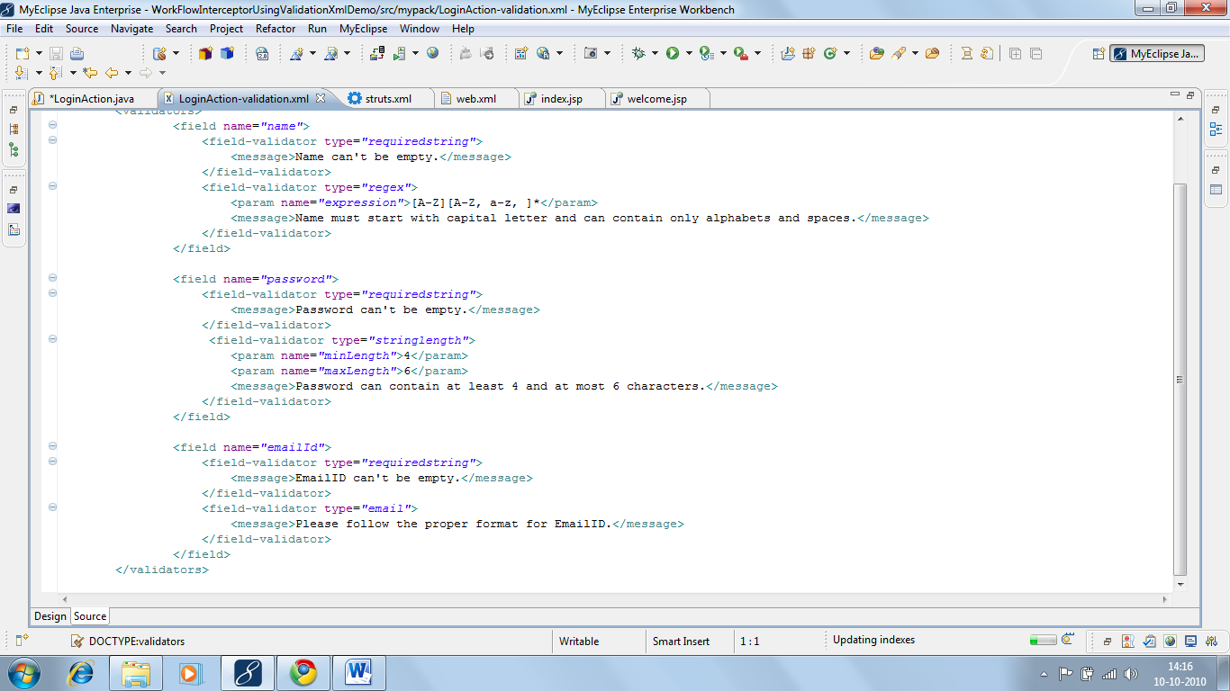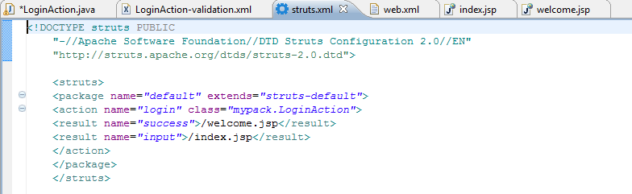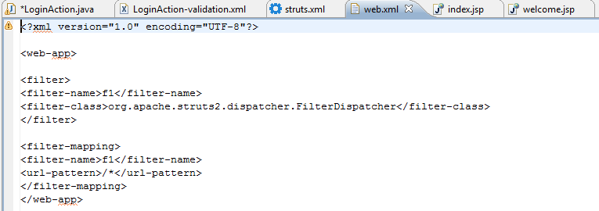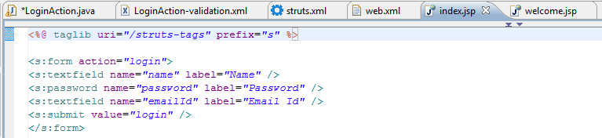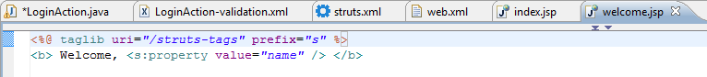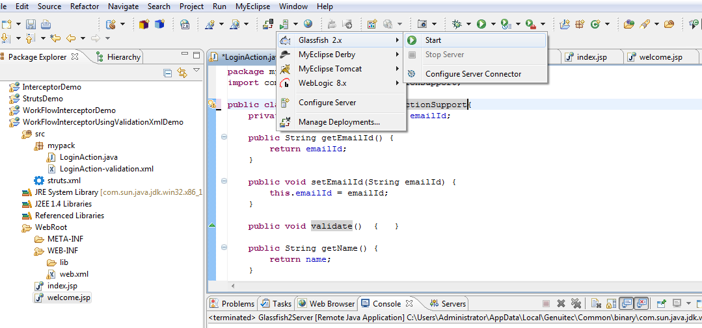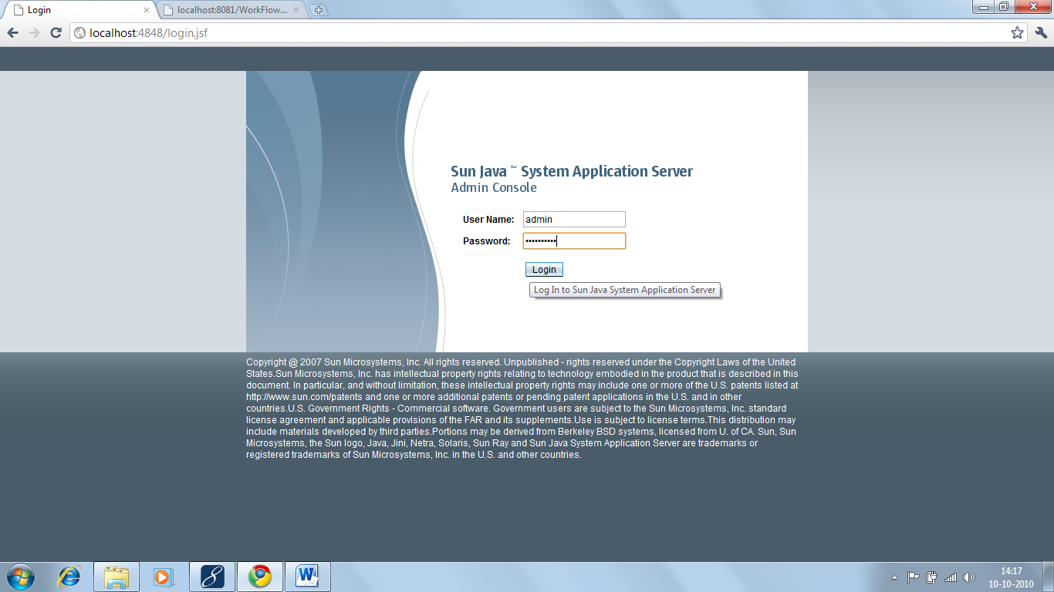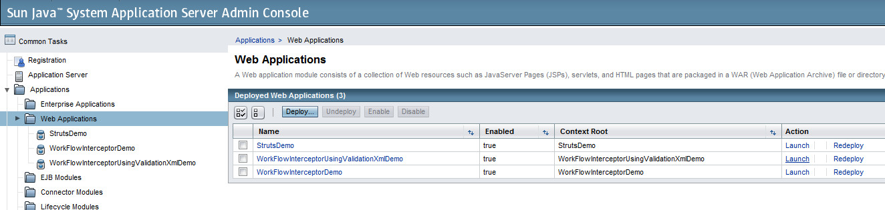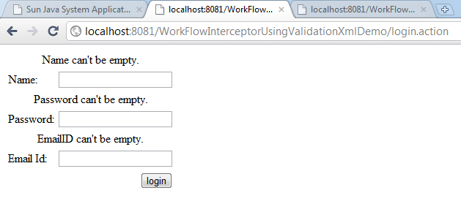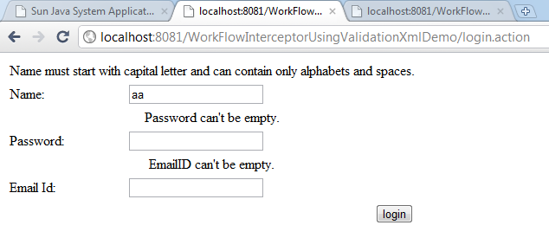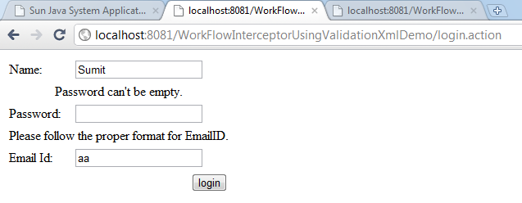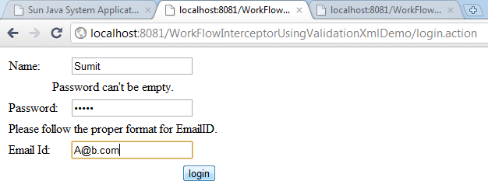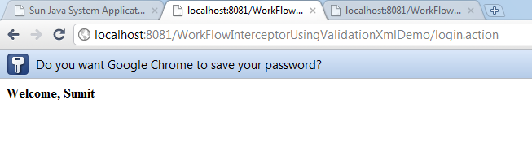
- Working with Regular expressions-
A Regular Expression is used to specify pattern that is used to match the value of a field.
Following symbols are used to define a Regular Expression –

[A–Z] | Represents a character between A to Z.
[A, B] | Represents either of these characters.
A { d } | Represents d occurrences of preceding character.
A * | Represents 0 or more occurrences of preceding character.
etc.

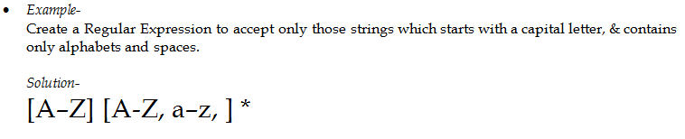

Dated:10.10.10
- Tiles - is an optional sub framework of struts that is used to generate composite view. A composite view is a page that contains contents of multiple pages.
In Commercial Web Application most of the pages which are presented to the end-user are composite views.

- Problem: Usually composite views are defined by dividing a page into different regions and including contents using “include action” or “include directive”.
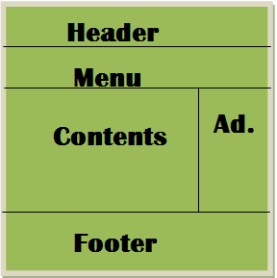

This approach results in maintanence problem if layout of the pages is to be changed frequently.
Tiles Framework solves this problem by facilitating change of layout of individual pages without modifying them.

- Terminology related to tiles-
  - tiles layout – tiles layout is a JSP Page that defines a layout for composite views. This JSP page divides a view into multiple regions, each of which contains a placeholder for displaying a tile.
  - tile – A tile is a JSP page or simply string contents which are to be displayed in a region of the composite view.
  - tile definition – A tile definition is a XML file that contains the mapping of tiles & plceholders for a tile layout.
  - tiles result - is a specific result that uses a tiles definition, tiles layout & tiles for generating a composite view.

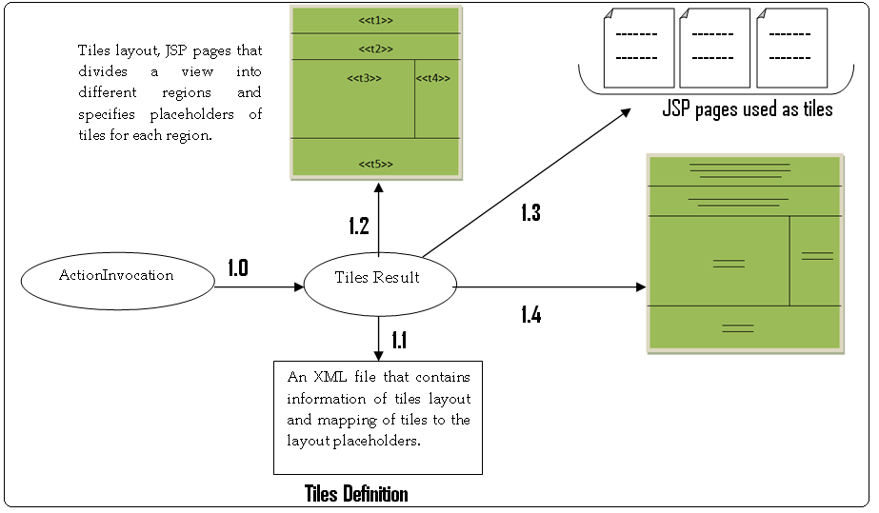
1.0 | Result is invoked and name of definition is provided.
1.1 | Tiles definition is read to find out layout and tiles.
1.2 | Layout is read.
1.3 | Tiles referenced by definition are read.
1.4 | Composite view according to the layout is generated.

Steps to use tiles in a Struts Application-
  - In addition to Struts jar files, add tiles plug-in jar files.
  - To enable tiles plug-in add the following listener element to web.xml
  - Define a layout JSP page that uses Tiles Custom Tags for creating placeholders for tiles.
  - Define JSP pages to be used as tiles.
  - Create an XML file named tiles.xml to define tiles definitions.
  - In the struts.xml file use TilesResult to generate composite views using the defined definitions.

Example-

- USING CONVENTIONS FOR PROVIDING CONFIGURATION INFORMATION TO THE STRUTS.

Following steps are required to create a zero configuration application-
  - Add Struts Configuration plugin jar file in addition to struts jar files.
  - Define action classes in packages named action, actions, struts, or struts2. All the action classes either have action as suffix in their name or must implement Action interface provided by the framework.
  - All JSP pages which are used by the results to generate view must be saved in a folder named context under WEB-INF.
  - JSP pages must be named according to the following convention.
ActionName-StringReturnedbyAction.jsp

Example
If “ok” and “error” are returned by LoginAction then JSP pages should be named:
login-ok.jsp
login-error.jsp

- Using annotations to define configuration information
  - Add struts-convention plugin jar file in addition to struts jar files.
  - Define action classes, JSP pages according to your own convention & store them in the packages and folders of your own choice.
  - Define a property file named struts.properties under the classes folder. In this property file specify location of action classes and JSP pages.

struts.properties
struts.convention.package.locators=mypack
struts.convention.result.path=/jspPages
struts.convention.action.mapAllMatches=true

  - In the action classes use action annotation to specify configuration information .

- execAndWait interceptor is used to display temperorary result while an action is being processed.
Sometimes processing of an action takes a lot of time. Hence it become imperative to provide some feedback to the end-user so that he/she doesn’t become impatient.
This interceptor when invoked first time starts a new thread and invokes action from this thread and without waiting for the action to complete it returns a string wait from its own. This string is mapped to a JSP page which contains http meta tag that request the same action after specified period of time resulting in the invocation of executeAndWait interceptor again. This time interceptor checks if action is completed then it returns the string returned by the action otherwise returns wait again.

- Figure
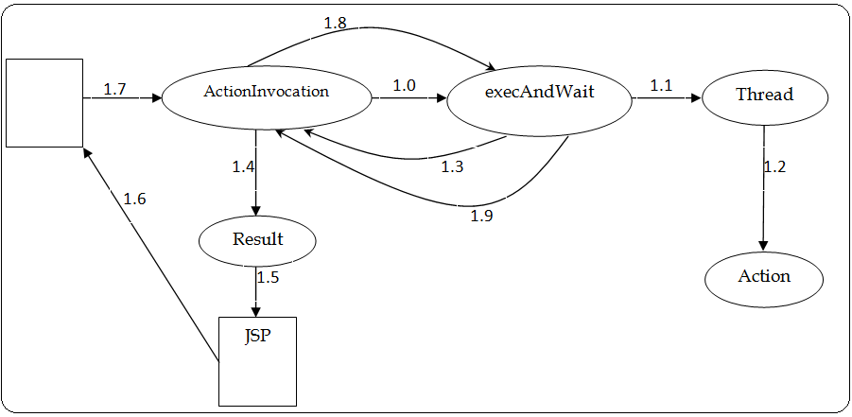
1.0 | Invoked first time.
1.1 | Starts a new thread and gets the action invoked from this thread.
1.2 | execute ( );
1.3 | Without waiting for the thread to complete, wait is returned.
1.4 | Result is invoked.
1.5 | JSP is invoked.
1.6 | A view is generated which contains http meta refresh tag.
1.7 | After specified time, a request for the same action is generated by Meta Tag.
1.8 | Interceptor is invoked again.
1.9 | If action is completed, String returned by the action is returned otherwise, wait is returned again.

